How to get names from dictionary personal details of names and id

1. Create variable of type array to crate dictionary

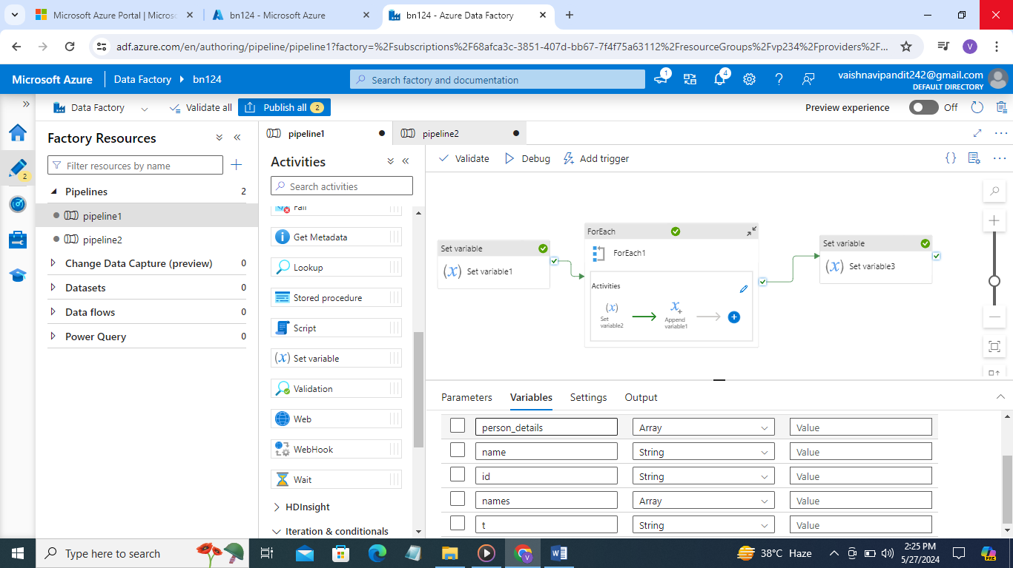

1. Then add value using set variable activity

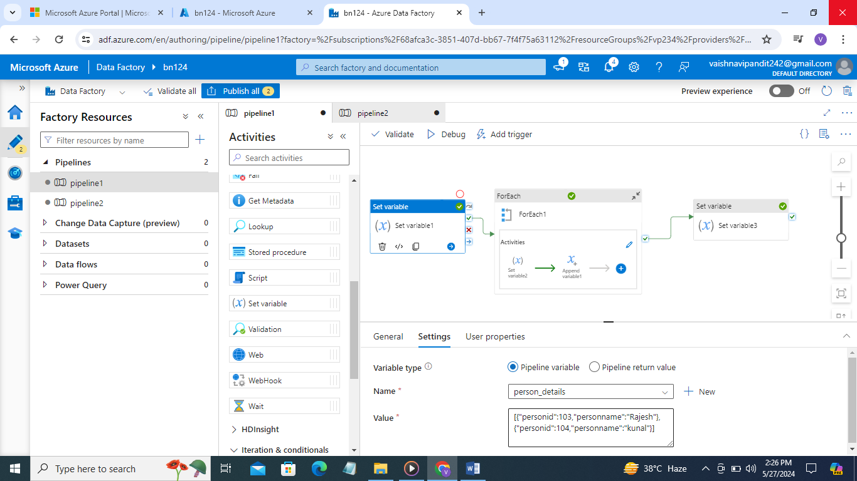

1. Now create for each activity

Go to settings add variable personal details

Select sequential

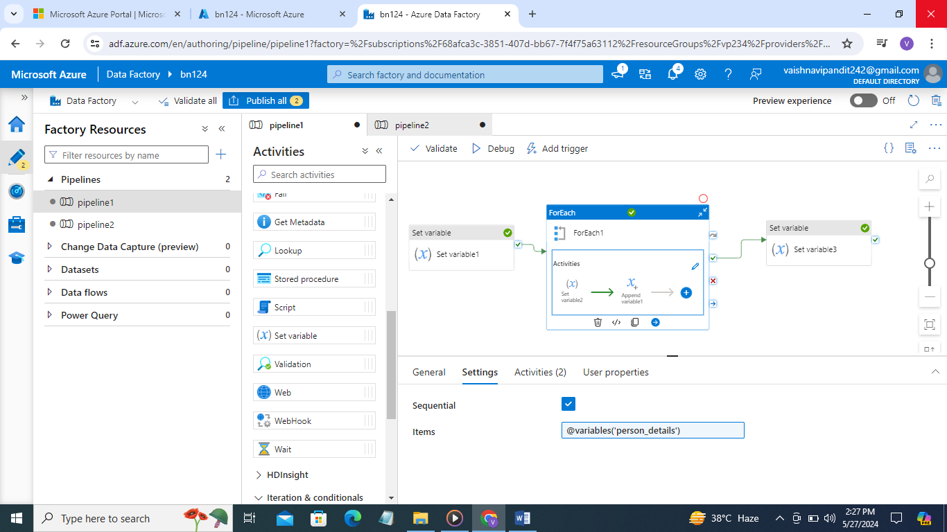

1. Create variable name for person name and set activity to add value items().personname

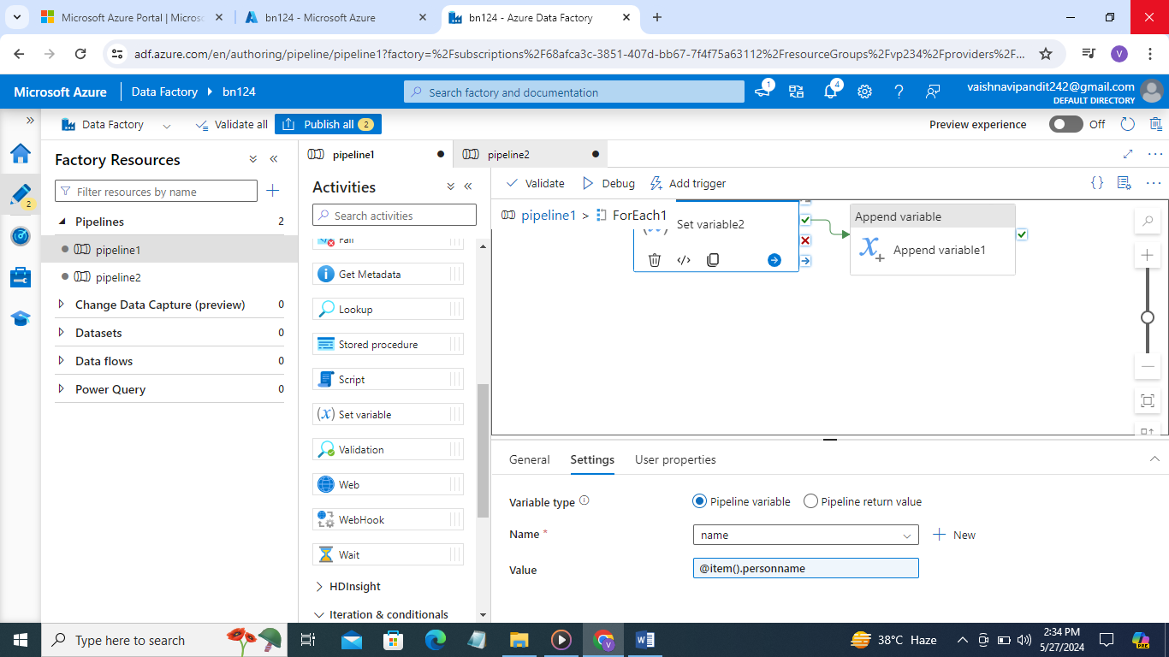

1. Now create one more array variable and append variable activity to add names in it

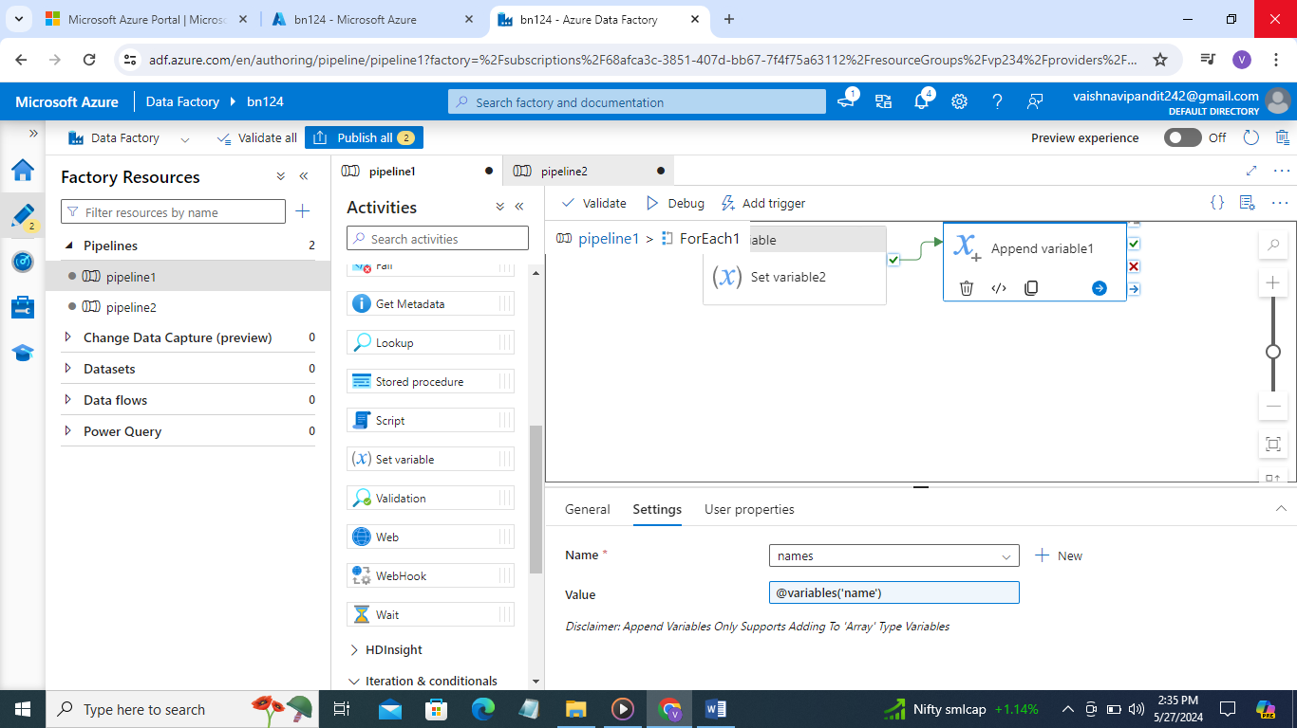

1. Now create set variable activity outside for each to write message person names are and add variable list of names

